Sound ~ /r/
The two most common tongue placements for production of the /r/ sound are pictured below. Sometimes prompting a child to pretend his/her tongue is a basket with an egg in the middle works for helping him/her figure out the bunched position. If one position does not appear to be working after multiple attempts, it may be worth trying the second position.
Bunched
Tongue is pulled back and the tip disappears. The sides should be touching the upper side teeth (in the picture, the child’s are not touching, but it is a good start). The tongue is essentially smiling.
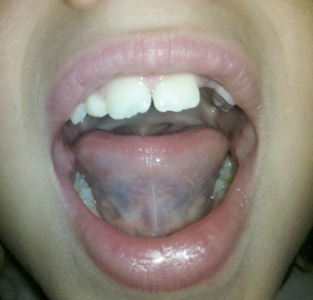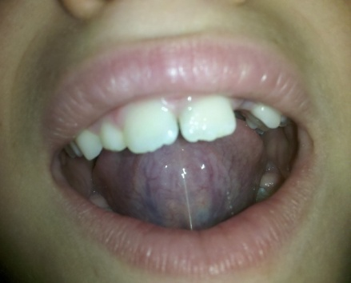
Bunched or Retracted Retroflex
Retroflex
Tongue tip is up and you should not be able to see it. The trick with this placement is that the sides of the tongue still have to touch the upper back teeth. The tip of the tongue should not touch the roof of the mouth. Middle of the mouth placement is crucial here as too far back yields a glottal and too far front yields an /l/ or an /l/-like sound associated with each /r/ if the tongue flips down too fast.
Targeting /r/ at home
Using a mirror to ensure accurate tongue positioning and to provide the child with visual feedback can be helpful at times. Also, it is important to keep /r/ practice as enjoyable for the child as possible. Often, targeting practice in the context of a turn-taking game (almost any game will work) can be useful. Usually, with this format, the child is simply encouraged to attempt to make the /r/ sound prior to each turn. The parent can provide accurate models of /r/ when it is his/her turn. Also, a hierarchy is followed: first, the child is encouraged to make the /r/ sound in single words. Once he has mastered the sound at that level, /r/ is targeted in short phrases and then in sentences. Once he has mastered /r/ at each of those levels, accurate production can finally be focused on at the conversational level.
Remember to keep practice as fun as possible. If the child begins to become frustrated, it may be best to take a few turns without practicing /r/ or to stop practicing /r/ altogether for the rest of the day. It is also important to congratulate the child whenever he does produce /r/ accurately and to give him positive feedback for working hard.

